What is API ?

When we learn programming languages or when we work on real world project’s or application’s that time we hear about API, API, API and Just API.

Some of people’s are know what is API but some another are Don’t know what is API,

Hey Don’t Worried about that I’m here, so today we will talk on API. Let’s go and start…….

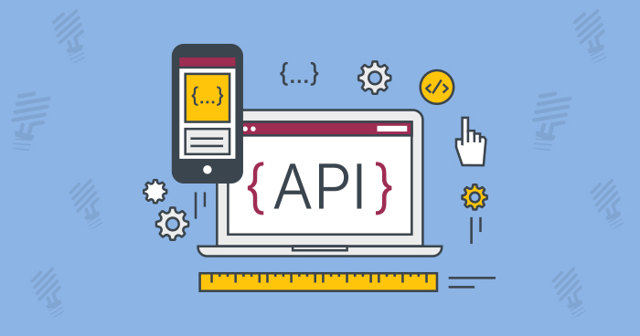

Which topic we will cover in this Article:

1. What is API?
2. How API work?
3. Advantages of API?
4. Type of API?
5. What is API end point?
6. Finally we will List some of free API’s

**What is API?**

API is that mechanism who enable two software component’s to communicate with each other using the set of Definition’s and Protocol’s.

For Example: Weather Bureau’s, this bureau software system shows daily weather data. And the weather application’s Talk to this system via API and shows you daily weather update’s on your phone.

API: Application Programming Interface.

**Working of API?**

We just see what is API and also we understand this through the two example’s because this is most important to understand and now we will see how actually API’s are Work?

API architecture’s are usually explained or understand in the term of Client and Server. The application send the request is called client, and the system send the response is called server.

In weather example, the Bureaus system is like server or weather application’s are client’s who send send’s the request.

There are four ways API can work:

1. SOAP API:
2. this API stand for Simple Object Access Protocol.
3. Client and server exchange the messages using XML.
4. This API is less flexible, that was most popular in past.
5. RPC API:
6. This API stand for Remote Procedure Calls.
7. In this API client complete the function on server, and server return back the output to the Client.
8. Websocket API:
9. This API is uses the JSON object’s to pass the Data.
10. This API support the Two Way’s communication between client and server.
11. Most important thing in this API is, server can send the callback messages to connected client’s which make this API more efficient than REST API’s.
12. REST API’s:
13. This Stand, Representational State of Transfer.
14. In todays web world this API is most popular and flexible.
15. In this API, client send the request to server as Data.
16. And server use this Data to start the internal function or work and return output data back to the Client.
17. This defines the set of function’s like GET, PUT, DELETE, etc.

(if you want special article on REST API, then comment Below)

**Advantages of API?**

1. Automation:

* With API’s humans as well as computer’s can manage their work.
* Also through the API’s agencies can update their work flow to make them quicker.

1. Application:

* API’s can access the app component’s that’s why the delivery of service and information is more flexible.

1. Efficiency:

* When access provide to API, the content generated can be published automatically and is available for every channel.
* This allows to be shared and distributed more easily.

1. Adaptation:

* Needs change over time and APIs help to anticipate the changes.
* When working with this technology, data migration is supported better, and the information is reviewed more closely.
* In short, APIs are make service provision more flexible.

**Type’s of API?**

API’s are classified both according to their architecture and Scope of use. We already see the main types of API architecture above now we just look at scope of use.

1. Private API.
2. Public API.
3. Partner API.
4. Composite API.

**API End Point?**

API endpoints are the final touchpoints in the API communication system. These include server URL, services, and other specific digital locations from where information is sent and received between systems.

API endpoints are critical to enterprises for two main reasons:

1. Security:
2. API endpoints make the system vulnerable to attack.
3. API monitoring is crucial for preventing misuse.
4. Performance:
5. API endpoints, especially high traffic ones, can affect system performance.

**Free API’s?**

1. Yahoo Search Marketing API: you can access Yahoo marketing data, also you can use to manage your marketing campaigns.
2. Google API: Google offers a wide range of open APIs that make it easier to work with Google’s many products. From Blogger, to AMP, to AdSense, to Maps, etc.

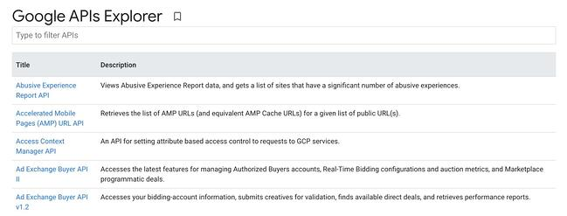

1. Telegram API: Telegram is a messaging service with two APIs. The first is the Bot API, which lets you connect bots to Telegram allow you to use the messages as an interface.

The second is the Telegram API that lets you build your own version of Telegram with full customization of the design.

